Photo
Seal
Born
County
City
c/o Mailing Address/Address

First Name+ Mi/Middle+ Last Name

Recording Number

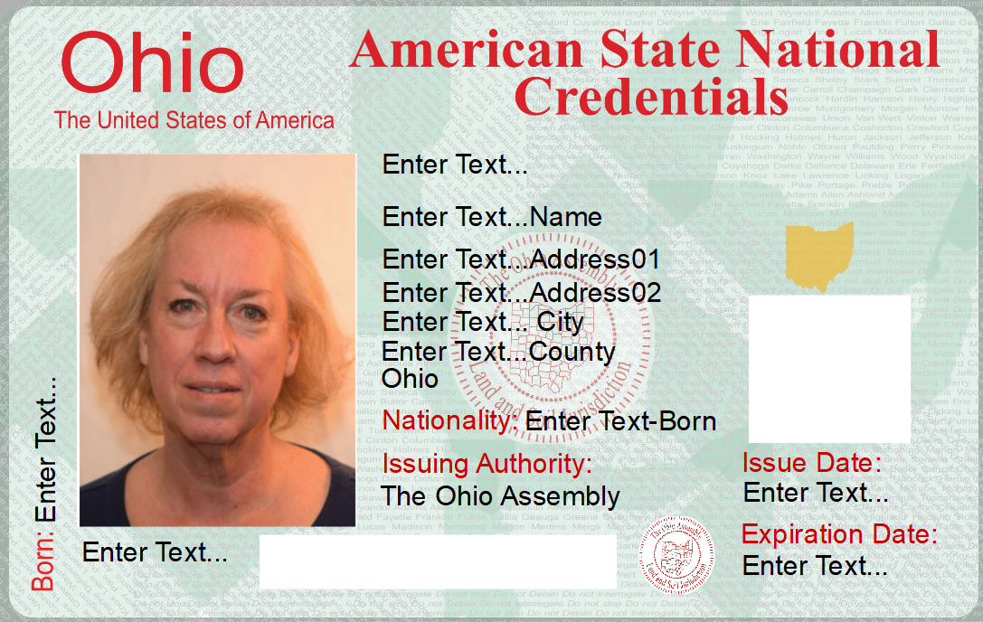
Signature: by:
Nationality
Sex = Man, Woman, Girl, Boy

Print Credential Card Date + 99 years
Print Credential Card Date

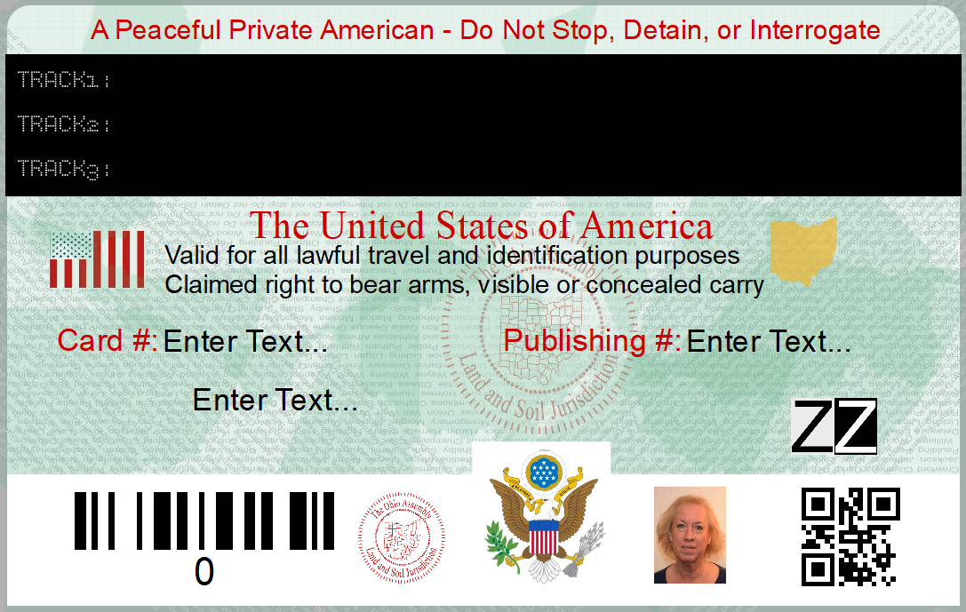

PDF417 – All demographic info
QR Code of URL to Paperwork
Photo
Last Name+ Born+Recording Number
Recording Number
Master Credential Card Number

Security features:
Hologram
Microprint (88 Counties/ Do Not Stop, Do not Detain, Do not Interrogate
Overlapping Color Overlay

