Published May 20, 2025
This Report
Global Bank Status: Land Commerce Initiative
Anna’s warning not to accept $5,000 “DOGE Saving” =Fake Nesara
Ombudsman
Witness Statements in the form of Video Affidavit Testimony
Concerning Public Duty
Nominations are open
State vs. County
Training
Concerning New Members and Recording
Concerning Trump/PKTF
Concerning Jurisdiction of Union State vs International State
Concerning Body Electors
Concerning Warning Signs of Fraud: State oversight committee Perjury, Paltering, and trespass. Article, in house nonsense
How Model County Leadership is building Clark County
Law Education: 8th District court, Notices, and using de-facto plates
Lawful Notice Terminology
Attachments: Minutes 5/16/2025 meeting
Organization Chart

Concerning Global Family Group & Banking in General
A request to open the GFG channel for prosperity union to Rockie Roper State Coordinator Chair has been sent. The Nevada Assembly and The Clark County Assembly are not receiving public trust funds due to the gross malfeasance of Sue Hulsebus. This means the State and County will be delayed in public trust funds, but individuals will still be receiving their private trust funds. This will require you to donate your own funds to the running of the government now for a longer period of time.
Banking Liaison Denise Mraz in accordance with Q2 directives initiates Land Commerce for outreach, please see below. This initiative requires 6 volunteers to assist with development and distribution and recruitment.
Nevada Model County Land Commerce Initiative

Volunteers are being sought to develop and deploy the Land Commerce Initiative. The program invites commercially minded individuals to come along side current business systems and evolve into partial and full land commerce ecosystem partners.

Global Family Group based Land Commerce Plan
These are two projects plus a marketing message Loan to Grant:
- Establish a new Business System which is based on AFD and has a GFG presence.
- Existing Business System adds/ incorporates AFD and GFG and continues normal operations.
Outreach is formulating a Land Commerce Conversion Program that names the business on GFG thru an ASN, Establishes an AFD channel for the business, demonstrates how to deal with the bank, how to handle employees, and employee benefits, tax advisement, insurance, and bonding, licensing, regulatory agencies. This Commerce Way Forward will succinctly address the concerns and questions of business owners to evolve land commerce and capitulate
This builds the ecosystem for Prosperity Union funds and Prosperity Accounts. A natural “come along side” progression of raising awareness for how to work with AFD based economy.
Precious metals are fluctuating so market pricing based on value will be a value-added system.

This is a second project affiliated with the above projects and also will be addressed in the Prosperity Union of GFG
C) Loan to Grant Program – Humanitarian Projects with milestones met and outlined to exceed agreed expectations of loan request participants.

Model County recruitment efforts will springboard local business outreach to develop new outlets for AFD and invite new ASN. International Business will be the State Committee and National State (County) Business will focus on local based businesses, or franchise or sole proprietor plus schools, farms, food, and fun.

Warm Regards,
Denise Mraz

Denise Mraz
The Nevada Assembly Banking Liaison
Assembly Outreach Chairwoman
Oversight Committee
Denise.Mraz@tccnva.org

Concerning Fake NESARA/DOGE Savings offer
Anna warned all of us in the coordinator call 5/ 15/2025 and following up with this article the next day that even though the municipal trust, “dead baby scam” had been conquered and liquidated. Trump had tried to pull fast one and appeared at The Hague and represented himself as the territorial representative receiver of the Cesti Qui Vie trust into the British Territorial Article 5359 https://annavonreitz.com/quellconfusion.pdf and what has come to light is there is another British substitution fraud to attempt to have Americans take the tiny purse belonging to the Seamans Trust in exchange for our purse and public trust and private trust described as decadent trillions---money to the moon and back.
$5000 payment is being advertised as a DOGE Savings by GOP, This is an enticement distribution of a fractional portion of your claim to the decedent St., Germain and Avila Trust and all the other trusts. So, it is a substitution fraud claim scam, another one. People are asking if they can write accepted to value and towards the debt I am owed. We are asking the question.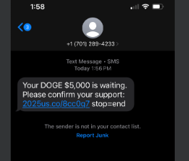 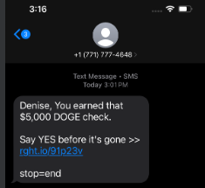

WARNING WARNING WARNING If you decide to take the Dead Baby Scam IRS based payment $5000 it is from the IRS. It will contract you with the Municipal and the Territorial and nullify your ASN status. Even if you took it under an alias, it would still nullify your status. That’s because it looks like a “savings” or other payment, but it’s still a contract and even if it magically appears into your bank account, you still need.
You will be contracting to accept the payment and there is no accepting it for value without levy or prejudice since it is a final payout- there is no account for it to go back to. The municipal and territorial will then convert this acceptance as payment in full of your private trust fund and then the only money that you could possibly get would be through the public trust charity.
In some states, that public trust fund will be delayed (Nevada is one of those states) since the bank was working with coordinators who did not respond to the bank. Anna will be absolutely shocked when she learns the people close to her were denying funds and access to funds to ASN. Further, there are still coordinators in place using stall protocols and other divisive tactics to be sure people aren’t working together.
All I can say is there are/were many misled people, and they did wrong for all their own reasons. To say they didn’t know is no excuse. If you hear or see something, then our American Way is to go to the person and express your grievance for truth.
Also, apologize for your mistakes, if you did wrong publicly, then apologize publicly. If you did wrong privately. Then do the same. Offer restitution and remedy.
And if you are still learning the American Way, then observe and get into the books.
The spoken and written word are binding, and the self-mastery and discipline are needed.

Concerning Ombudsman

Please keep in mind as a member of Model County (Clark County Nevada) you may also submit any claim to ombudsservice@proton.me in confidence. The claim support process is here:
- Ombuds service request email needs to say in subject line: OMBUDS SERVICE REQUEST (all caps).
- You will state in the body of the email (no attachments-the email will be more secure and easier to track if all communication is written in the body of the email) what your conflict is in discreet and self-governing terms.
In the body of the email as “How Do I Resolve This?”
Identify parties and places something like this as an idea:
- Yourself as “I”
- Transgressor 1, Transgressor 2, so on
- Witness 1, Witness 2, so on
- Bystander 1, Bystander 2, so on
- Location 1, Location 2, so on
Describe the conflict as clearly as you can, in a chronological order of events. Do not send any attachments for evidence. As a matter of fact, don’t send any evidence. If you want, you can copy and paste screenshots into the body of the email, but screenshots cannot have any names of people or places or office titles. That kind of identifying information must be redacted. The screenshot needs to show dates and times.
This claim support is the Ombud can assist you with identifying the elements and claims of a crime.

Concerning How to Create A Witness Statement in the form of an affidavit
Handwritten Witness Statement with your wet ink signature and testimony states your name, date and.
When you start your video or statement, use this at the beginning.
"I ____________________, a living woman/man on _____________________. I am an American National. My witness and testimony freely and voluntarily without duress and without any hidden purpose. In this presentation, I am telling the truth and the whole truth to the best of my ability to know the truth, in order to create and provide a video deposition for the use of courts and prosecutors worldwide."
- Transgressor(s)
- Witness(es)
- Bystanders (es)
- Harm incurred
- Damage Incurred
- Remedy sought
Email it to oversight@theclarkcountynvgov.land
Video witness testimony description
Send video with transcription attachment (you may use AI) and a Handwritten Witness Cover Sheet with your wet ink signature. The video should be in an mp4 file format and please include the above statement.
Email it to oversight@theclarkcountynvgov.land
This is a way for you to not only be heard, but to make being heard count toward prosecution. Make it more than a story or an interview, make it a deposition.
Concerning Public Duty
County members have an obligation by the Prudent Man Rule and Law of Kinds in deference to the Law of the Land. In American Common Law when we see something, we say something.
Living men and women who bear witness to facts and truth are standing in honor when proclaiming these truths.

Nominations are open until May 31, 2025
Elections are happening soon. The process is publishing the roles, nominating, vetting, voting then results posting. If you would like to run for a one-year term, please send us a note at outreach@theclarkcountynevadagov.land
Positions available: (Appointed by Committee*) Underline positions are ASC status ^Elected ~Non-Elected Volunteer
County Only (All pro tem until election)
Chairman Bruno Nolte
Public Notary Pam Banks
Sheriff Keith Van Love
Elections Chair Carolyn St John*v
Treasurer^ Michelle Schmidt
Court Clerk ^Vacant
Vetting Chair*v Robert Lentkis
Ombudsman Scott Johnson & Pauline White
Bondsman^ Frederico Gonzales
Ed & Planning Chair*v Alexe Kulikov
Secretary/RK ^Christina DeMaria
Banking Denise Mraz*v
County Militia Liaison Mindy Robinson
Jural Secretary^ Vacant
Reg Z Process Max Taylor*v
Jurors Chair v Vacant
Litigation Committee Chair*~ Vacant
IT Committee Chair *v James Hu
Law Ed Chair *~ Jonathan Watson
Oversight Committee Chair *~ Denise Mraz
Recording Secretary Chair * v Aaron Lucey
Justice of The Peace*~ Pauline White Leanne Slusher Scott Johnson
Coroner^ Nader Rouhani
Land Patent Office ~ Bruno Nolte
Court Venue~ Denise Mraz
Court Recorder^ Vacant
Outreach Committee Chair*~
County Facilitator~ Rockie Roper Michelle Schmidt
Committee of the Whole All Chairs, Chairman and MAA

Electors and Delegates will be chosen from these positions. All positions except Coordinator require a Jural Assembly Member Agreement & 928. No vetting is required for committee members or chairs, vetting only needed for elected roles.
All non-elected roles are nomination/acceptance by Regular County Assembly or General State Assembly
Business International Assembly (all pro tem nominations)
State Coordinator /Co-Coordinator v Rockie Roper, Tamara Amaral
Committee of The Whole v (All positions plus 2 ASN Delegates*~V from each county)
Assembly Militia Commander ^ Shallon Bent
Treasurer^ Michelle Schmidt
Secretary^ Vacant
Chairman^ Bruno Nolte
Marshal at Arms^ Matthew Mitchell
PKTF Liaison Jennifer Olson

If members wish to self-nominate, please advise the elections@theclarkcountynvgov.land or elections@thenevadaassemblygov.land

The structure of the Role is to have a committee for each position.
Please note we have received nominations for Public Notary-Pam Banks, Coroner-Nader Rouhani, Shallon Bent –State Milita Commander, Mindy Robinson-Clark County Militia Liaison, Rockie Roper –State Coordinator, Ashley Painter-Coordinator, Tamara Amaral- Recording Secretary, Michelle Schmidt Treasurer, Keith Love Sheriff, Tamara Amaral- County Facilitator, Robert Lentkis- Vetting Chair, Aaron Lucey-Recording Secretary, Max Taylor-Reg Z Plates, Leanne Slusher-Justice of the Peace(Multiple needed), Pauline White-Ombudsman(Multiple Needed),

All offices are for a one-year term. Successive years may accumulate.
-The process and method of election is nomination, posting, voting day, results publishing.
-There will be a published video meeting of candidates.
-There will be a live video meeting of interactive public testimony concerning the candidates in which the public can bring up concerns and the candidates may respond.
Voting and nominations are received at elections@theclarkcountynvgov.land for all roles statewide for this first election, which will be online. If you aren’t from Clark, you may adopt the JAMA until such time as your County adopts their own, or doesn’t, TCCNVA is the only county currently that has a Jural Assembly at the moment and would hear any such cases at this time. Some of our counties don’t even have anyone on them so it’s going to be a while before counties will be able to populate their county to the point of having a jural assembly and any ASN may request that a standing County Jural Assembly may hear a case. The ombudsman service is for anyone in the state since we have that as a service of Model County from PKTF.
Nominations are now being taken and until June 15, 2025
Elections are on June 17, 2025 location TBD.
If you accept the nomination and/or election, please:
- Submit your signed jural assembly agreement,
- Your validation you are on LRO
- Your video bio or your written bio.
Posted May 19, 2025.

Concerning State vs. County (Soil and Land Jurisdiction)
We are one in spirit of peaceful assembly to uphold Public Law. The Federation initially established 50 State Assemblies with Counties. The top-down idea worked in some states and broke down in other states. The Current Model County builds the Counties and the International Business State Assembly (IBSA), and the State Militia Assembly (SMA). Other 4 pillar models exist with many committees forming in a General Assembly, but for the short term we are focusing on building the Counties with IBSA, SMA, and the State General Assembly will be populated later, when it is necessary for it to convene.
The IBSA is necessary and vital for the protection of the Nation (Union of County State) from International Trespass.
Concerning Training
Please find training information for all positions at https://rcinnsight.com/ train Nevada Password@1234

Concerning Recording New Members & Assistance With LRO
Your right to Assemble is violated when you are denied any assembly of other Nationals in your county or state. So, we please ask recording secretaries to connect new members with a quick email to outreach recordingsecretary@theclarkcountynvgov.land so there is a point of contact. Please note you will be placed on the email list as you are a fiduciary, and we have an obligation under public duty to inform you.
PKTF Communication
https://pktfnews.org/
Concerning Jurisdiction: Union State & International State
; Federation roll called: The Nevada General Assembly Land and Soil Jurisdiction, The United States of America, unincorporated to provide a Federation interface from a General Assembly that was supposed to originate from People in Counties getting stood up. In many states, this ended up being a club of controllers. It’s not actually 4 pillars; it’s really just two pillars. The evolution of a Federation interface now is being determined and having a Coordinator to reset the Business International Assembly and Assembly Militia with a State run Jural Assembly after the Counties get stood up. When counties are stood, they will require an interface. Currently, no interface is needed, and the protocol is currently being developed.

Nevada has two State Assemblies, a Nation State. The Nation State is a Union State-union of the Counties), and an International State, all power rests with the People. The counties create the Nation State, then send their delegates to Congress. The International State is an outside world international interface and is called The International State Business Assembly. People is supreme to any Assembly, county or state. The business of the Assembly should never run over its members, especially twice!

When Land is added to a role(officer/appointee) or Assembly, they become international; therefore, there are no living people on a land jurisdiction, only soil contains living people. So any form of International State is comprised of and overseen by electors/delegates from soil to union of soil equivalents (counties made of towns of People). Any International State Assembly is a corporate entity of unincorporated people and they volunteer there in a capacity of lawful persons.

; County: The Clark County Nevada Assembly, The United States, Unincorporated (a union nation of towns populated by People) possess all authority and have a public duty to exercise it, this local county government is made of People from towns.

; Towns are the soil where People live. The interface of People is the County, comprised of towns.

; Counties elect Delegates/Electors to oversee the Federation International State Assembly and all its functions, and any form of subversion of a County and its People is a grievance to redress through due process beginning with private communication.
https://annavonreitz.com/guidanceforassemblies.pdf

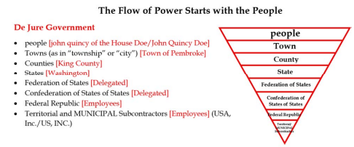

Concerning Sovereign Body Electors (www.annavonreitz.com)
Article 2778 https://annavonreitz.com/soeveryoneknows.pdf Perhaps you also realize the urgent need to organize and restore your actual, factual government and exercise your position as a Body Sovereign Elector and sponsor Public Elections for your State Legislature and fill the long-vacant Deputy offices to serve in your actual Congress.
We don't need huge numbers of people (though we would like that) who are qualified to speak for their States of the Union. A minimal quorum of thirty to thirty-five qualified Electors is desired, but in a pinch, even one qualified Elector can invoke the power of the entire State under The Last Man Standing Rule. To be a qualified Elector of your State of the Union and of The United States of America (bear in mind, these rules have not changed since 1860 and can't be changed until we convene a Continental Congress to change them) you need to: (1) be able to prove that you had ancestors who were here and either born on the land of a state or fully naturalized State Citizens prior to 1860; (2) that you are a landowner; (3) that you claim your birthright political status; (4) that you are at least 21 years of age; (5) that you are a free man --- not indentured or enslaved -- which was generally assumed for Caucasians; (6) and are male. Our research indicates that contrary to what was believed initially, race was not the controlling issue prior to 1860 with regard to Elector status. Any man could always be an Elector, so long as he was not enslaved and not indentured. His status as a Free Man was the controlling issue. Women were never Electors though they could own land and other property. Until a legitimately formed and styled Continental Congress can make changes, these are the rules, and we need to abide by them.

That doesn't mean that you cannot or should not join your State Assembly if you aren't able to act as a qualified Elector. The Electors need the support and insight and assistance of everyone else to do their jobs. Electors are Fiduciaries for their States and bear a great responsibility. The rest of us can help them by doing research, building the supporting organization, providing transportation and meeting spaces, even cleaning the toilets and fixing lunch.
There are a myriad needs and tasks that need to be fulfilled and there's nobody here but us chickens to do it all. All those Federal and Federated State and incorporated County Employees that are ultimately on our payroll to provide us with "government services" operate in a totally different jurisdiction and literally can't do any of our actual work of self-governance for us. Our initial efforts to organize the States located a minimum of a few men in each of the pre- 1860 States sufficient to make the claim on behalf of the States. This supplements earlier work done to establish the continuity of the evidence of our lawful government from before 1860 to today by the Nation States project and numerous other efforts.
To get connected to the National Assembly effort send an email with your County and State as the subject line or visit (Since this article was written Clark County, you can now get to http://www.theclarkcountynvassembly.org/)
Make the effort to correct your political status and then join and get your County and State Assembly up and move as part of the National Assembly. And if you can, have some pity on me and the members of The Living Law Firm who have been in the field non-stop for decades, unpaid, working to protect and preserve our Ship of State from the international pirates who have so nearly succeeded in literally stealing America. The current circumstance is straining our resources to the utter limits, and we need your help --in all respects-- if we are to succeed. Send cash donations CASH APP or via Snail Mail to: Anna Maria Riezinger, c/o Box 520994, Big Lake, Alaska 99652. Send information --- historical documents, government publications, case citations and other bits and pieces that you consider important to: Anna Maria Riezinger, c/o 1336 Staubbach Circle, Anchorage, Alaska 99508.
Local Donations to your county assembly can be made to coordinator@TheClarkCountyAssembly.land

Concerning Warning Signs of Fraud: State oversight committee Perjury, Paltering, and trespass.
http://www.paulstramer.net/2025/05/in-house-nonsense.html
We follow Bouvier Law Dictionary https://www.1215.org/lawnotes/bouvier/bouvier_c.htm
The State Oversight Committee Mark Seilstad, Jill Horsley Chairwoman, Jeannine Gardella and also General Assembly Chairperson Brian Vonarx who oversees all the committees committed fraud on 5/11/2025 when they published an email where they removed from context an action of recourse and then applied it in an email citing a report from Teri Sahm who is their friend and chairs the Federation Vetting Committee. Teri used her position of authority in malfeasance and went outside her jurisdiction of vetting to deceitfully apply the terms District Assembly to actual authentic assemblies. Her friend Sue Hulsebus assisted her with an escalation of plagiarism and fraud by materially changing communication of Anna Von Reitz in public meetings 4/5/2025 where she manipulated members while her friend Jill Horsley and Kathi Kridler stood by like zombie dead fish and watched her, then participated in the fraud. Additionally, all mentioned here never publicly denounced the illegal and unlawful act of their choosing to extend an invitation to contract issued May1- May10. It is the American Way that if you see something, say something. All the above people are to be noticed by the Assembly for malfeasance, fraud and trespass.
The Oversight Committee claim: “Anna's final recourse for Rockie Roper and Denise Mraz is: Returning their paperwork with the seals and dates and numbers crossed out and cross their names off the Assembly list.”
THIS IS A MANIPULATION Called Paltering.
FACT The wordsmithing of the document, a manipulation, published by Jill Horsley and Brian Vonarx, likely authored by another person, using all assembly members as her proxy, is written to deceive readers. An untrained reader would believe claim ‘Anna’s recourse’ is equivalent to meaning “Anna wants Rockie/Denise to capitulate because of alleged crimes”. Rockie and Denise never committed any crimes. Anna is in communication with Rockie and Denise.
What is happening here is deceit, gross breach of trust of office and malfeasance of position of trust, false witness and perjury. At the same time, an invitation to contract from Sue Hulsebus with the Nevada Assembly, and this was all escalating, Carlos Guzman wrote an offer the Rockie Roper to “create a new Assembly with the de-facto” which was publicly rejected at a meeting because it had to be. A coordinator receiving an offer to contract will always be brought to the public.
The author/publisher took the intent of Anna’s recourse as should be applied to a transgressor, but Rockie and Denise are not transgressors, so this would not apply to them.
They are simply exercising their inherited rights of people on the land to sand up their county and state, and they do so in truth.
FACT Anna has been lied to all along by FSC and MAA (Sue and Doug Hulsebus), and also by Teri Sahm defending the fraud actions of FSC/FMAA and the fraud of weaponizing vetting and other compelled processes and manipulation of LRO to achieve a blockade. FSC has continually manipulated information, created ‘evidence’ out of context to twist the facts to support her false witness narratives.
FACT This false statement supported by Jill, Mark, Jeannine and Brian concerning the removal of Rockie/Denise was rebuked by Anna Marie Reizinger on May 13, 2025, in following text Exhibit: 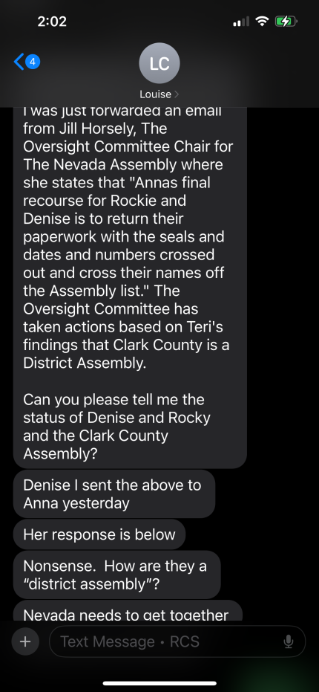

How Model County Leadership actively builds Clark County
We will write notices and communicate effectively with all people to best serve the assembly.
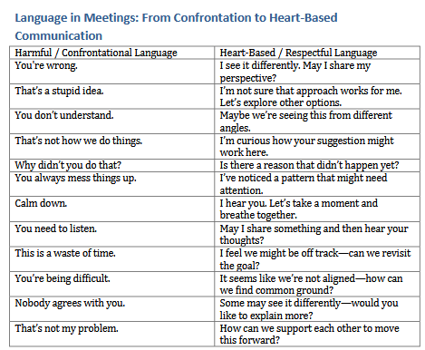

Concerning Website
A new website template is being adopted please contact outreach@theclarkcountynevadagov.land for information on the new website

Law Education and Related Lawful Justice
The Sheriff’s Department is undergoing training, and the deputy offices are fully staffed at this time.
TCCNVA handbooks are being developed for elections, Coroner and other roles and will be adopted at a special purpose meeting.

How to use de-facto plates with the APCMD Sticker 42 minutes on https://m.youtube.com/watch?v=0biVrYCJoIo

Lessons for Getting Your Land Legs - Due Process 101 Monday's at 4:00p m Pacific | 5:00 pm Mountain | 6:00 pm Central | 7:00 pm Eastern Kristi's Personal Room kristi-861.my.webex.com/meet/Kristi | 25585702889 Join by video system Dial mailto:Kristi.kristi-861.my@webex.com and enter your host PIN . You can also dial 173.243.2.68 and enter your meeting number. Join by phone +1-650-479-3208 United States Toll Access code: 2558 570 2889

Assembly Law Notices And/or in the Form of Motions
WE are working on a standardized notice for ease of Use. If you would like to work on it with law education, please contact oversight@theclarkcountynevadagov.land
Notices are in process for a number of fraudulent and perjury trespasses concerning the state oversight committee and their collusive living people.

Terminology: Harm and injury
Paltering -using truthful statements to create a misleading impression
Self-oriented lies. Lies of Omission Manipulations Compulsive Lies Exaggeration Fabrication
Lies of Commission (making false statements) Fraud
Trespass Mischaracterizing intent and actions Accepting Vetting w/out min .requirements
Fraudulent Lies= perjury

5357. International Public Notice: Two Lanes Full http://annavonreitz.com/twolanesfull.pdf
Under the black magic money spell https://www.youtube.com/shorts/3C58XDOIokM
5358. International Public Notice: Order Demanding Arrest of Domestic and International Terrorists http://annavonreitz.com/orderdemandingarrest.pdf
Link to David Martin's presentation: https://rumble.com/v681rta-dr.-david-martin-the-who-was-founded-by-the-cartel-as-a-criminal-organizati.html
Link to text of presentation and associated evidence: https://mega.nz/file/B4FDlJTC#YOephouNY8qIYMDqWHx0GyN8UDnc8qMQc74UqQD85bo

5364. International Public Notice: What We Said to the Universal Information Field http://annavonreitz.com/universalinformation.pdf
Link to Nassim Harramein https://nassimharamein.com/
The Unified Spacememory Network: from cosmogenesis to consciousness: https://spacefed.com/isf-research/the-unified-spacememory-network-from-cosmogenesis-to-consciousness/
Nassim Harramein Research Papers: https://spacefed.com/isf-research/
Link to the Law of One: https://www.llresearch.org/
Link to Law of One Resources: https://www.lawofone.info/
Link to Thrive Movement and Movies: https://www.freetothrive.com/

Published May 8, 2025
Outreach Committee
Additional Notes:
Jural Membership Agreement
Agenda
Minutes
All forms

