The Nevada Assembly Business Meeting
Online June 3, 2025, 6:30 pm
Online meetings with Free Conference Call
The meeting link is: https://join.freeconferencecall.com/rockier
This link never changes (508) 924-3161 Store these numbers in your photos or phone and
Please note that once the meeting starts if you try to call me I’m conducting the meeting and cannot help you log on, we open the meeting at 6:25pm
6:30 pm General & Business Meeting Agenda

Call to Assembly: by a TCCNVA
Bivens Decision:
Purpose for meeting or meeting name: The Nevada Assembly
This meeting is called in honor of the people who are owed a republican form of government and peaceably assemble to restore their government. Your mindful comments are welcome. We welcome any additions you wish to have placed on the agenda. Be it known we believe in a transparent government and a vibrant discourse, therefore if you speak in public and are not in honor you can be held liable for your discourse and actions.
Prior to the meeting please read the following information and be prepared to discuss them:
- Talk about Anna’s information to Rockie. Everyone needs to see and hear this information. Let’s all work together to build our state up. Article included.
- Talk about the new article about 2 States and jurisdictions. YES 2 States.
- Treasurer
- Restore Treasury with chain of custody letter
- Letter to Summoning Authority re: the Federation Account
- Banking Liaison Update
- Model County Advancements:
- State Assembly State of Union Role is to handle International Business (corporations and contractors and sub contractors),
file:///C:/Users/Owner/Downloads/TheAmericanGovernmentResurgencReferenceGuide.pdf
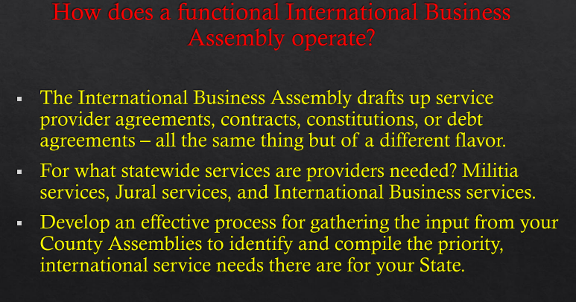
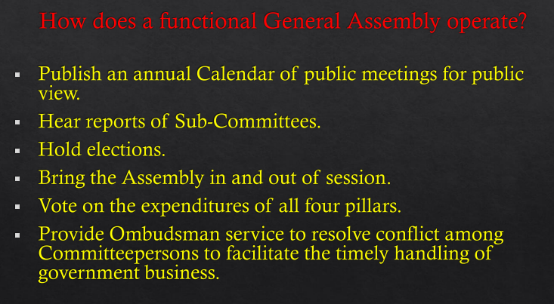

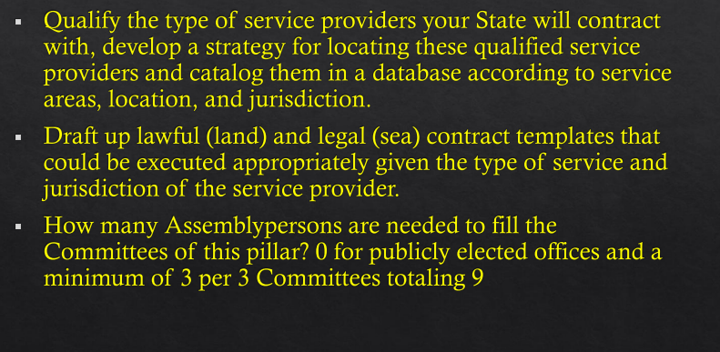
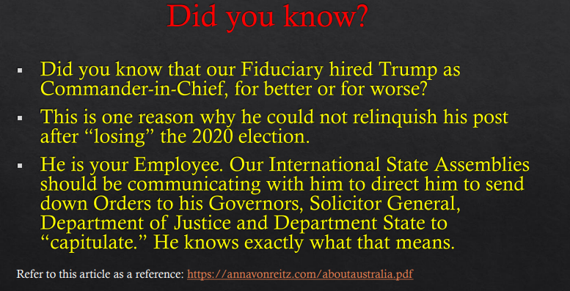

- Nation Union State handles issues regarding the living people

- State Militia Report
- Committee Reports
Banking
Elections
Public Notces
Oversight
Outreach
PKTF Liason

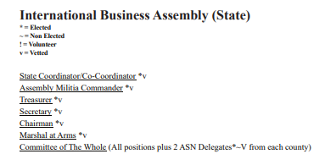

Outreach
Global Family Group Business Package

Contact:
coordinator@thenevadaassemblygov.land
outreach@thenevadaassemblygov.land
recordingsecretary@thenevadaassemblygov.land
oversight@thenevadaassemblygov.land
coroner@thenevadaassemblygov.land

Old Business
New Business
Adjournment

