The work of the people in Nevada Union State!
About 4 years ago, the people on Clark County started questioning the processes of building our Counties and our State Assemblies. As you may know, building a home without a good foundation doesn’t work.
We all came to the conclusion, that for our State to be the strongest, we needed all the Counties to support the building process. As you know, when we bring a man or woman back to the Land jurisdiction, we are also bringing them to the Soil jurisdiction. So, what we all have come up with is “let’s build both the Counties and the State“ to their fullest at the same time.
Let us explain the reason behind this process on building the Counties (Union State). As you may or may not know, we start with the people in our General Assembly, our first pillar, the people who live in towns and all the people in those towns come together and build the Counties they live in. This also then starts to snowball and when the people in those counties come together, they build their State Assemblies as well. This is the foundation we believe the process should be, when we are working together as brothers and sisters and getting to know each other you will be a stronger group of people that give themselves a much better chance of taking on whatever comes to the assembly. As you know, every assembly faces many challenges and if we do not address and repair the challenges between us, we will not be able to face the world in our Counties or State Assembly. The end goal is to have our States up and running with the support of strong Counties in our State. This is where the Union State came to light because all the Counties form The Union State.
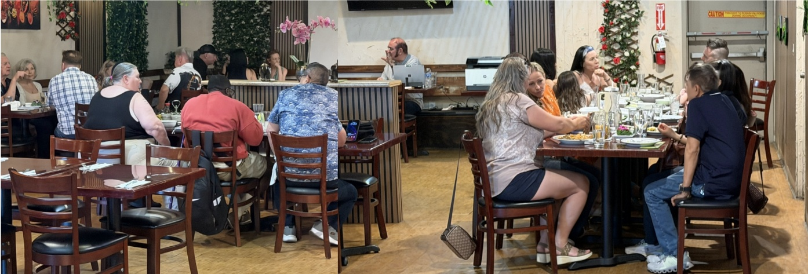
So, as the people on Clark County and adjoining counties came to realize, as you will as well, that working together to build the Counties simultaneously with making your State even stronger is the way to proceed.
Start with working on identifying what the goals are in your state and what all the people want and or need in your Counties and State as we have done here in Nevada. We realized that we all had the same goals, we just weren’t working together to accomplish our goals. Everyone needs to come back to the Soil and be real with themselves and one another. Work together to support each other, get to know one another, we all come from the same Creator, and he has given us all we needed to know on how to stand together as one “forsake not the fellowship of the brethren”
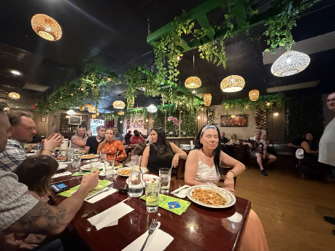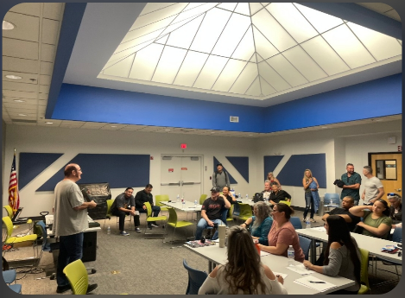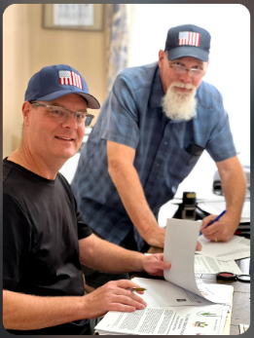
Standing together as one, is the only way to get all of this work done. Craig, our original guide and mentor, who showed us nothing but teamwork, passion, love for us and our state, drilled the process into every single one of us and also trained every one of us in Nevada that we needed to come together as one. And when we did, things started to magnify in unity and work incredibly well for Nevada. That made us all stronger. As we realized, together no one could break us apart. All together we had the hands, feet and all parts needed to stand together. That was the catalyst for us all standing together today.
Now let’s get into how we made this happen, building our Counties (Union State) and State together. We used all the information from Anna and broke it down into what we could do as a group and started the building process of creating the government we all wanted. We all wanted to be FREE from the current government and their bondage as all of their processes did not let us be FREE. So, we started with the strongest part of our government, the Jural Assembly. We all have a starting point and know what is needed to build that pillar to make our government strong. We need a Sheriff in the counties as the sheriff has the power to protect us if we all stand behind the office of the Sheriff.
We need all the people to stand in for our Jury. All of the people in the assembly came up with an agreement and wanted it to be a part of our asn process. They wanted the agreement to be signed so that we could get a count of people ready to serve in our courts. Then we looked at what else we needed to build these pillars. Court Clerks, Justice of the peace, bondsman, ombudsman, and coroner. We made this quick chart of our courtroom to see where we stood on people needed to complete this process.
Quote from Keith Love - Clark County Sheriff
“It has been my honor to serve as our
Clark County Assembly Sheriff and experience
the full support of our Assembly,
together there’s nothing we can’t do”

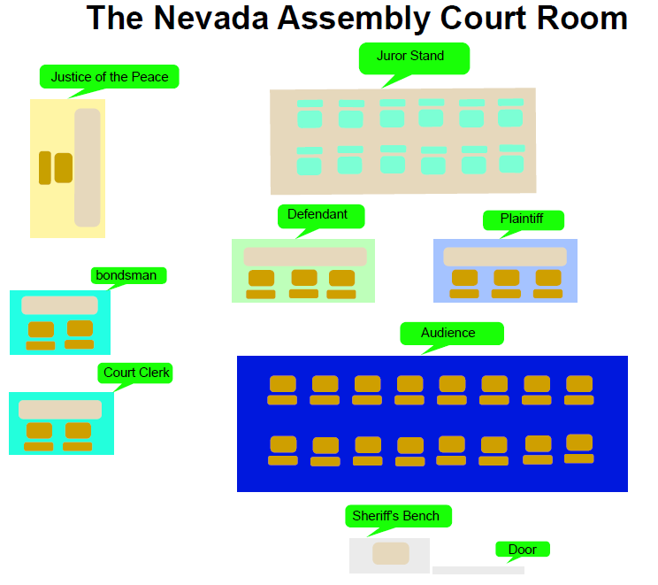
We all went to work to complete this project of getting the Jury assembly built. It made things a lot easier when we identified and focused on what it is we were trying to get done. Working all together and doing what it takes to make it happen. As you can see, our courtroom does not look anything like the current de facto courtroom. The reasoning is when reviewing the processes, we realized the Jury and the defendant are the main focus of the court room. That is why they are centered and in front of everything. You will notice that the Justice of the Peace is off to the side. The Justice of the Peace has an important part in the court process. Even though they are the key player in the court, they do not have the power in the court room, the jury does. Once we had the people in these positions we started on the next pillars. We needed the Militia which again is the people in your Counties and State. So, we organized the Militia by getting someone that is good in bringing people together to help assist in responding to disasters and protection of our counties and state resources and people. With this information and reflection Nevada hopes that every county and state will come together as one to build your State Nations. If you have noticed, not once, have we mentioned the word coordinator. We haven’t said anything about a coordinator in this process because building your Counties and your State has to do with the people not a coordinator. The coordinator is there to help the people get the information we need to build the assembly correctly so not one man or woman in the state gets harmed in any way. Craig Schmidt was that man for us in Clark County and Nevada, to bring us all together and get the information we needed.
Nevada’s words to you all are:” Come together as one and start working together. We’re here for you!’
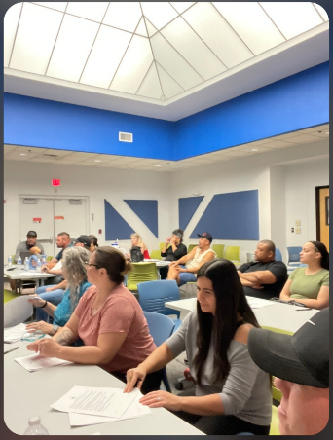
Quote from Jennifer Phillips
Sometime in 2023 Craig Schmidt had mentioned to me about joining the assembly, I was unsure about it at the time because it was unfamiliar to me, like anything unfamiliar, it’s human nature to be hesitant, but Craig being Craig, he kept reminding me and was gently persuading me that this is very important to me and my birth right to come back on the land and soil, he had such a way of explaining things to me that I became eager to know more, I really didn’t ever think it could be possible for me to be free, to self-govern, but it is, and it is possible for anyone who is willing to correct their status. I have been learning so much about our growing assembly, and there is still so much to learn, helping to build our Assembly is so critical and it is an honor to be able to carry on something that was so important to Craig, who was also my Dad, he was so passionate about building our Union State and County Assembly, and I want to share with others what he loved and knew we all needed.

